

FACULTY OF COMPUTING
SEMSTER 1 2025/2026

Design Thinking Project Report

Project Title : Smart Parking on Campus

COURSE CODE & SECTION : SECP1513-02
COURSE : TECHNOLOGY AND INFORMATION SYSTEM
LECTURER’S NAME : DR. ARYATI BINTI BAKRI
GROUP’S NAME : DATASYNERGY

 |  | 
NURAIN NABILAH BINTI AZMAN | LIM LI NING | NAJLA AUNI BINTI MOHAMAD ASRI
A25CS0324 | A25CS0249 | A25CS0117

Contents
1.0 Introduction 3
1.1 Background Information 3
1.2 About Us 3
1.3 Objective and Overview of This Project 3
2.0 Target Consumer 4
3.0 Problems and Solutions Problem 5
4.0 Team Working 7
5.0 Design Thinking 7
5.1 Design Thinking Process 7
5.1.1 Empathy 7
5.1.2 Define 8
5.1.3 Ideate 8
5.1.4 Prototype 9
5.1.5 Test 9
5.2 Design Thinking Evidence 9
5.2.1 Sample Work 9
5.2.2 Record for each phase 11
5.3 Design Thinking Assessment 26
5.3.1 During the end of the project demonstration 26
5.3.2 During the transition between design thinking phases 26
6.0 Reflections 27
7.0 References 29

1.0 Introduction

1.1 Background Information
According to the Facts and Figures UTM website, the number of student in 2025 about 30142 student studies in campus UTM. For the fresh student is not allow using their own transportation since the bus provided but the senior is allowed to taking their own transportation in the campus. Most of the senior using their transportation like car and motorcycle since more convinient and safely .They doesn’t need to wait for the bus and they can leave at any time to accommodate schedule changes whatever the class at night. However, the parking space of the campus is harder to find without any new system helping and most unpantiently during peak hour or large campus event make the overcrowded so leads to severe traffic congestion, resulting in significant time wasted in slow-moving or stalled traffic. So that to solve these of the problem ,our team decided to design an app named “CampusSpot” that help you in transportation or parking on campus.

1.2 About Us
“CampusSpot” is a smart parking and traffic management system which means it is an integrated, data-driven mobile and app that uses real-time sensors, predictive analytics and user feedback to optimize parking availability and reduce traffic congestion on campus. By designing specifically for campus environment, the system utilizes loT sensors installed in each parking space system and monitoring vehicle movement through strategic traffic sensors and existing CCTV infrastructure to collect data, which is processed through a cloud-based platform and made accessible via a dedicated mobile app. Through the app, users can check real-time availability 24 hour and receive intelligent navigation guidance that considers current traffic conditions. By significantly reducing time spent searching for parking, minimizing traffic congestion through intelligent routing, “CampusSpot” gives a smarter, more efficient, and sustainable mobility experience for the entire campus community.

1.3 Objective and Overview of This Project
The purpose of this project is to develop a smart parking system as well as a traffic flow management system with special emphasis on the needs of disabled students for accessibility on the campus. This key of this project will enhance accessibility features, including real-time availability of accessible spaces and campus traffic conditions. Thus, through the integration of IoT technology and data analysis, “CampusSpot” is going to provide a more updated and hassle-free campus mobility experience for students and staff. For instance, they can check for the availability of parking space, receive notifications for parking space availability, and use a route direction service for avoiding traffic congestions. The key feature of this project will include the incorporation of an smart navigation solution for the users, enabling them to have easy access to navigation solutions in order to avoid crowded traffic conditions.

2.0 Target Consumer
“CampusSpot” is created to satisfy the constant need for effective, easy, and intelligent options in managing parking on campus. This solution not only integrates data from sources from different places but also adds live tracking, thus resulting in a much easier parking experience. Mainly, the solution is directed toward college students, faculty, and visitors, and those who use their cars for daily commuting would be the ones benefiting the most from this solution. Consequently, the system plays the role of guiding the users to the available spots, hence cutting down the searching time, and reducing the traffic, especially during peak hours. Besides, by giving updates and making suggestions, “CampusSpot” has a part of users’ effective parking planning and decreasing the pressure caused by the lack of parking space.
In addition, “CampusSpot” is exactly what busy students attending consecutive classes and employees with rigid schedules who frequently run into the problem of not being able to park on the campus in need. It is targeted at the people who go through the same agony in the form of lost time, frustration, and uncertainty caused by packed parking lots. The system with its real-time availability tracking, smart parking recommendations, and notifications features improves user mobility and encourages proper time management. All in all, “CampusSpot” is a smartly designed and consumer-oriented modern solution that through intelligent means makes daily commuting to and from the campus pleasant.

3.0 Problems and Solutions Problem
Problem | Description | Solution
Difficulty in finding available parking spaces | Whether it is clear or not, the state of parking spaces on campus is one that is highly difficult to ascertain, particularly at peak times when the student or staff population is at its highest. Some drivers are forced to drive around the various parking places continuously, not knowing which ones are already full. The situation leads to a waste of time, to more pressure, and to people being late for their classes, meetings, or jobs, besides other things. This deficiency little by little cuts down daily productivity and lowers the campus life quality. | With the help of “CampusSpot”, users get always informed about the parking lots' status, which makes it easier for them to locate the empty places ahead of time even when the locations are already packed. The system retrieves and presents live data allowing the users to quickly choose based on the information. Consequently, it saves time on searching and enables users to proceed straight to the empty parking areas. Thus, the parking experience for the users is quicker, easier, and less annoying.
Campus traffic congestion | The continuous stream of vehicles searching for parking spots is the principal reason for traffic jams on university roads. Traffic jams during peak hours result in very slow movement for all vehicles and are also a major cause of accidents. Furthermore, prolonged driving is and more gas is consumed, and more pollution is emitted, thus the planet being harmed through these activities. Such a situation makes the commuting experience unpleasant for every campus user. | The system of “CampusSpot” employs intelligent suggestions that lead the users to the less occupied and more appropriate parking spots. The system not only reduces random driving but also the passing of cars around the parking lots, which automatically smooths the traffic to a point where it is safer and more orderly. Ultimately, the campus environment becomes more efficient and environmentally friendly.
Lack of real-time parking information | Mostly, the users depend on guesswork or their past experiences to choose parking places, which is not very accurate considering the dynamic parking demand. If there is no real-time data, the users will not know the condition of a specific parking area is occupied until they arrive at that spot. This scenario results in dissatisfaction and improper selections in the course of decision-making. The lack of clear information among users deteriorates their self-efficacy in the campus parking structures. | “CampusSpot” offers a unified and easy-to-use interface for real-time parking status. All the time, the system guarantees that the users are getting the right and current information. By having better visibility, the users can even choose suitable parking spots before they arrive at their target. This makes the system more reliable and increases the total user contentment.
Poor time management | The act of searching for a parking space eats up a lot of time which otherwise could have been used for study or work-related activities. The late arrival of students in classes can be one of the implications of this while staff may even lose the chance to attend meetings or appointments. This constant time loss not only adds up but also has a negative impact on daily scheduling and being on time. Poor time management in the end means less output and more stress. | “CampusSpot” sends notifications and predictive suggestions to help users plan their arrival times more effectively. Users can predict whether there will be parking spaces available and change their journey times accordingly. This helps to organize the day better and diminishes the chance of arriving late. So, users are able to handle their time more effectively and also more assurance.
Table 3.1 Problems and Solutions

4.0 Team Working
Teamwork is critically important for this project. Therefore, to optimize workflow efficiency, our group decided to divide tasks among ourselves. On 20/11/2025, we chose “Smart transportation or parking on campus” as our topic. Day by day, we began contributing ideas on how to implement the topic smoothly.
Najla was responsible for creating and distributing Google Form for data collection. Additionally, all members contributed by conducting real-time surveys through interviews with students and lecturers, with Li Ning leading the interviews. After that, we proceeded to develop the prototype. All group members also contributed to writing the report and creating presentation slides. For video, Nurain focused on video editing.
Throughout this design thinking process, we continuously supported each other to ensure everything progressed well. All collaborations were conducted online via our WhatsApp group.

5.0 Design Thinking

5.1 Design Thinking Process

5.1.1 Empathy
The first stage of the design thinking process, empathy, focuses on user-centric research. To gain a profound comprehension of the issue that we intend to resolve is the objective. The main aim of the empathy stage is to uncover the user, their needs and the hidden difficulties that have a say in the progress of the product we wish to develop.
Up to this time, we conduct user observations to deeply understand the users' environment and generate empathy. For this purpose, we developed a Google Form to gather data from the community, focusing on students who frequently drive to school. The survey allowed us to collect data on their everyday parking challenges, how long they spend looking for parking, trouble times, and proposals for improvements. Furthermore, our team did a brief interview with some UTM students and one UTM lecturer to better understand personal experiences, pains, and hopes regarding parking on campus.

Based on the survey responses and interview findings, we identified several recurring issues faced by users. These include difficulty in finding available parking spaces during peak hours, lack of real-time parking information, increased stress due to uncertainty, and time wastage caused by repeatedly circling parking areas. These insights helped our group better understand user pain points and guided the development of the “CampusSpot” prototype.

5.1.2 Define
During the Define stage, our group organized and analyzed the data gathered from the Empathy stage, such as the results of the survey and the feedback gathered from the interviews. We analyze our observations to identify and articulate the core problems faced by users. After collecting the data and conducting interviews, our team engages in a discussion to review results and determine the problems faced by the user, thereby developing the problem statement.

5.1.3 Ideate
The Ideate stage focuses on generating a wide range of ideas and potential solutions to address the problems identified during the Define stage. The main goal of our group at this point was to look for campus parking experience improvement, creative and practical ways. Starting from the foundational premise that the diversity of ideas is the best way to come up with the solutions, the team made sure that everyone was providing different opinions based on the user insights which had been collected earlier.

The group during the ideation process held brainstorming sessions proposing features and system functionalities that could efficiently deal with the problems identified. As a part of the strategies, there was the creation of a real-time parking availability display, smart parking recommendations, notification alerts for peak hours, and a user-friendly interface with clear visual indicators. Moreover, we discussed the feasibility and importance of each idea, considering the user's needs and technical limitations.

After the evaluation of ideas, our group went ahead to select the most effective and feasible solutions to be included into the “CampusSpot” prototype. The chosen ideas are mainly pinpointed to time-saving in parking search, better decision-making, and user friendliness. The problem was identified and the solution created through this phase acted as the connecting chain. It had a major impact on the design of a user-friendly and effective parking management system.

5.1.4 Prototype
The next stage is the Prototype phase, where we focus on identifying the best possible solutions for each of the problems we identified in the previous three steps. After our discussion, we concluded that developing a new application named “CampusSpot” will provide a better user experience and greater convenience compared to the other smart parking kiosks apk. In this step, we transform our ideas and concepts into something tangible. After our meeting about the design and features of our application, we created our design by using canva app which is easier for us to use.

5.1.5 Test
The final stage is testing, which is an essential step to help us ensure that our “CampusSpot” system functions efficiently. User testing helps us spot issues more effectively and would help in improvements accordingly. We created a tutorial video containing all the steps that would help the users follow it conveniently and give relevant feedback regarding it. We have shared our “CampusSpot” prototype with students and staff in campus. Most were satisfied with the solution, especially features like accessible parking navigation and streamlining traffic with smart routing.

5.2 Design Thinking Evidence

5.2.1 Sample Work
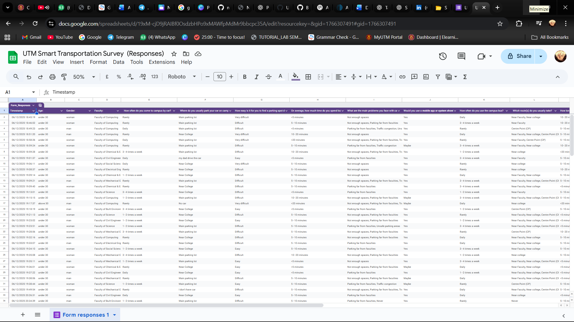 | Data Collection  We collected the problems faced by users and suggestions from them.
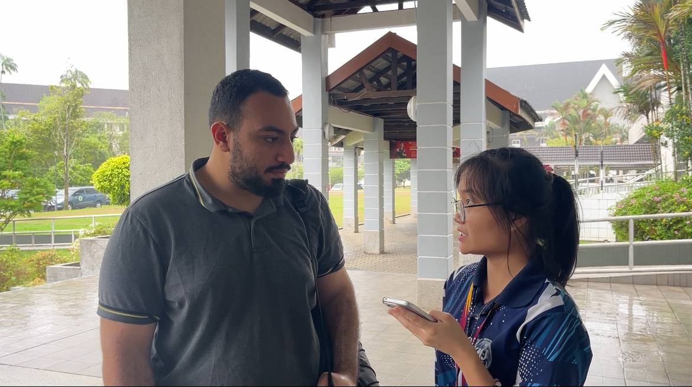 | Interview session  Interviewer: Lim Li Ning  Interviewee: Ahmad  We asked about the challenges he experienced while finding parking spaces on campus and his suggested solutions for improvement.
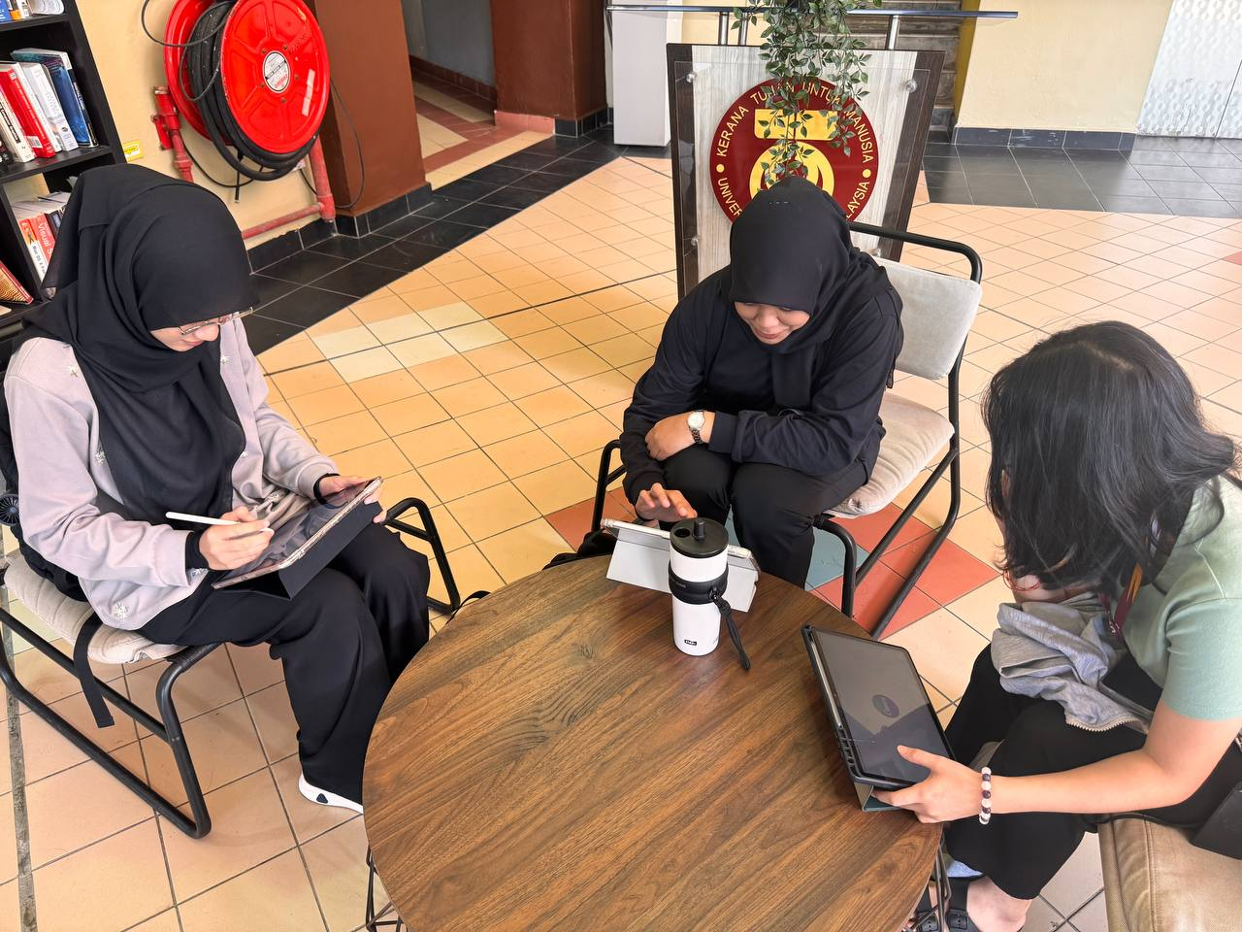 | Discussion  We chose the topic of smart parking on campus.
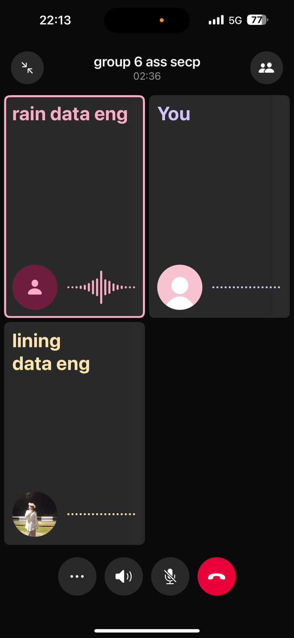 | Further Discussion  We analyzed the problems faced by users and listed out all possible solutions. Then we chose the best one after making a comparison.
 | Building a prototype  After the discussion, we started to build a prototype.
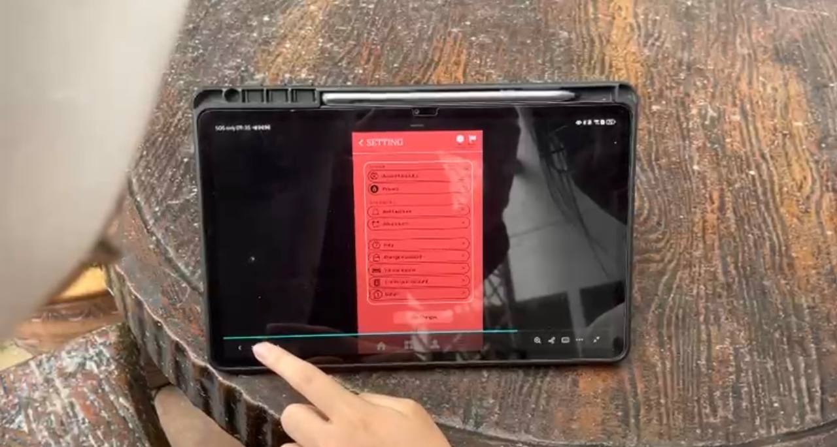 | Testing  When our prototype was done, we demonstrated and tested our prototype with different users.
Table 5.2.1 Design thinking evidence

5.2.2 Record for each phase
1. Empathy
For the Empathy phase, we conducted an interview session with three respondents who regularly face parking challenges in their daily lives. Below is the list of questions asked during the interview:
- On a scale of 1-10, how stressful is finding parking on campus during peak hours, and what specifically makes it stressful? (Respondent #1)

- Would you use a mobile app that shows real-time parking availability? Would you pay for premium features? (Respondent #2)
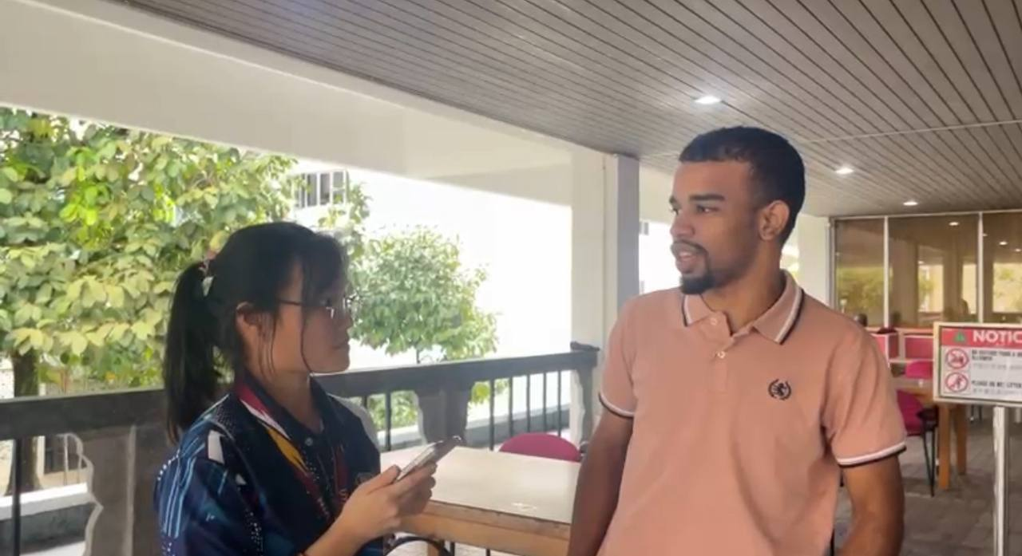

We also generated a survey using Google Forms to get more information from a wider range of people.

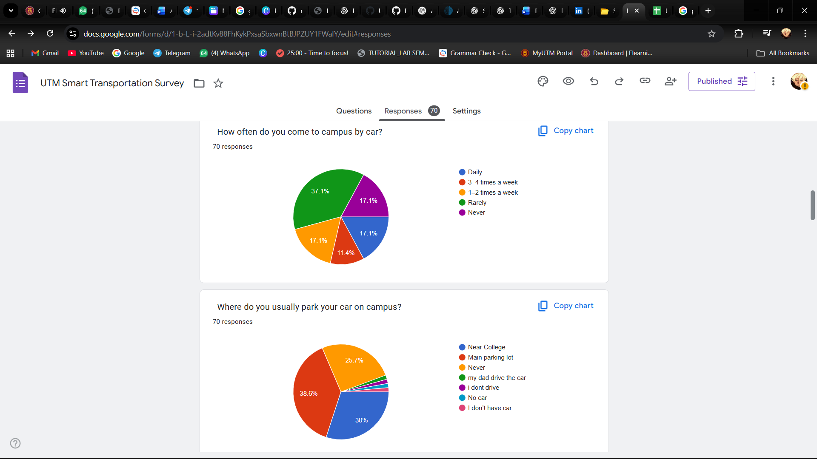

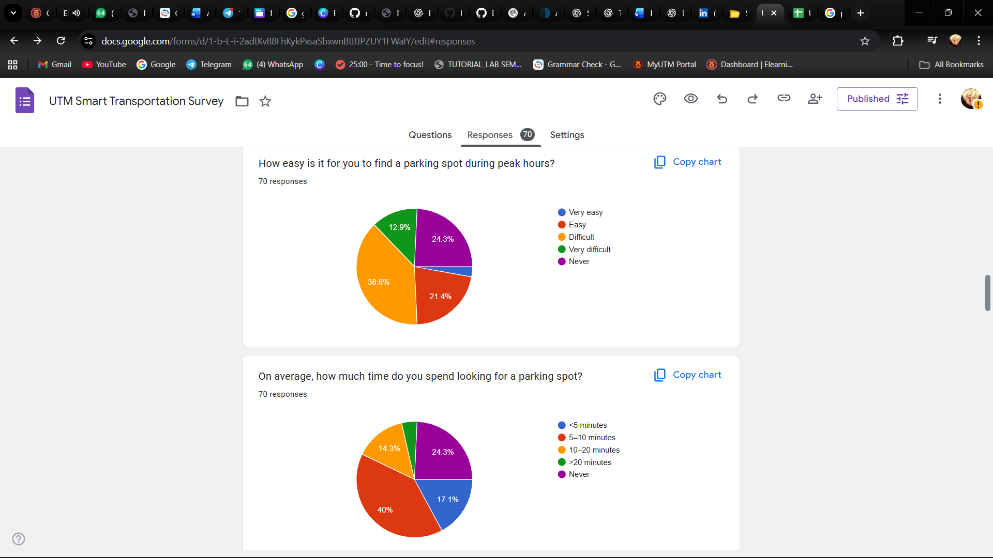

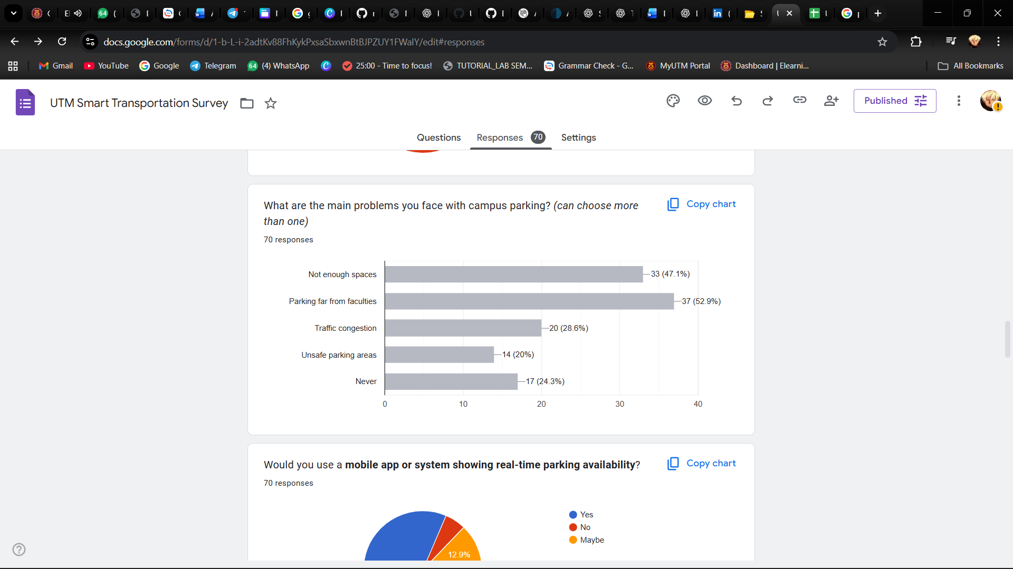
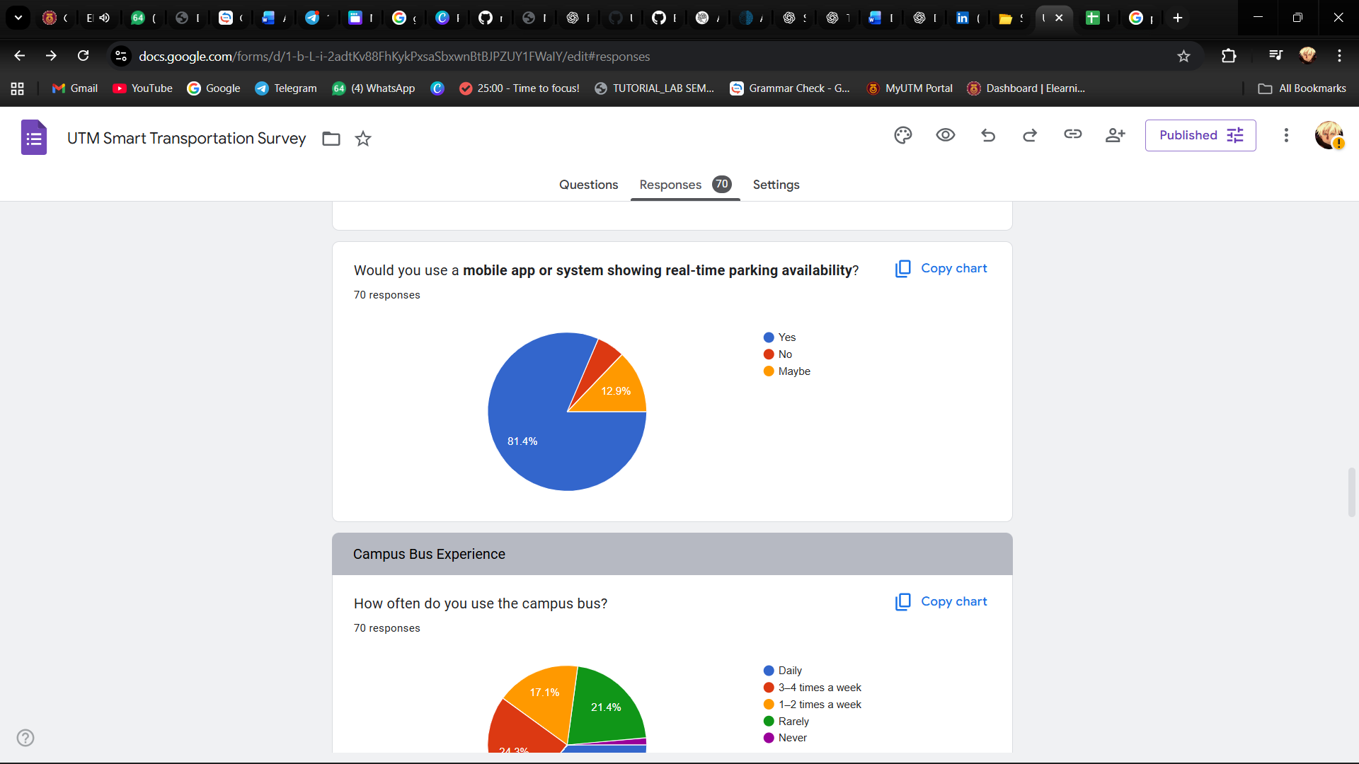

2. Define
The table below shows some problems that users faced.
PROBLEMS | DESCRIPTIONS
Unsafe parking areas | Some of the parking lots seem dangerous because of the absence of light. There is a need for security immediacies in order for there to be an all-round closed loop of safety and security to eliminate crimes like vandalism and car theft. This situation may lead to a situation where the students and staff would not park in those spots, mainly during the night. The establishment of safety measures is a need that if met, it will raise the users' trust level and additionally support the right usage of parking spaces.
Traffic congestion | Parking lots are mostly full stuffed during peak hours, and the people who are looking to park their vehicles are left to suffer in this scenario in respect to waiting times as well as their level of patience while looking for a parking slot. Not offering users immediate updates about the traffic situation or the best route to take can be really annoying. Under these conditions, it is essential to have suitable management and direction to minimize the delays and improve the quality of the parking process.
Parking far from faculties | A few parking spots located at the university are not near the faculty buildings and thus the users have no choice but to make a long walk to their destinations. The trouble is compounded if the weather is bad or the users are carrying heavy things. Elderly users and people with physical disabilities are the ones to feel the problem most. Consequently, these users may not move to the designated parking areas and instead use other ones that are farther away, which causes inefficient space allocation and overall convenience loss.
Not enough spaces | During peak hours, the available parking spots frequently cannot cater to the large number of cars. As a result, the users have to waste a lot of time looking for a parking spot which leads to frustration and time being unproductively used. Sometimes, the users might have no choice but to park in prohibited spots or to join the others in creating traffic jams on campus. The absence of any straightforward communication about parking slots filled or not adds to the problem making parking control ineffective and user too stressed of the situation.
Table 5.2.2.1 Problems and Description

3. Ideate
The table below shows the possible solutions that can be used to solve users’ problems.
PROBLEMS | SMART KIOSK SYSTEM | CAMPUSSPOT APP
Unsafe parking areas | The smart kiosk will inform the users of lit and monitored parking areas on a digital screen for them to make a safer choice. | The application marks parking spaces that are secure, well-lit, and under surveillance. It assists the drivers in selecting places that are less risky in terms of safety.
Traffic congestion | The smart kiosk introduces parking areas with real-time updates in relation to available routes with alternative options to avoid congestion. | The application gives immediate notification of traffic and recommends alternative routes with lesser traffic. The users can schedule their car park so as not to waste time.
Parking far from faculties | The smart kiosk displays available parking areas near faculties and guides users with digital signage. | The application displays parking areas near faculties that are vacant and let users choose parking spots for minimizing walking distance.
Not enough spaces | The smart kiosk serves in locating a vacant parking area as well as guides the individual to that specific area. | The application displays real-time available parking spaces. This allows users to quickly identify areas with vacant spots.
Table 5.2.2.2 Possible solutions to solve the problems
4.Prototype
After our discussion, we concluded that developing a new application would provide a better user experience and better convenience.
The reasons for the decision are showed in the table below:
REASONS | SMART KIOSK SYSTEM | CAMPUSSPOT APP
Cost-effectiveness | Need higher cost due to hardware, installation and ongoing physical maintenance. | Lower cost as only required software
Accessibility | Required finding specific kiosk spots on campus | Can be used anytime through smartphone so that no need to vist fixed locations in campus
Coverage | Limited area that near kiosk locations | Campus-wide, supports both indoor and outdoor navigation
Update And Maintence | Required on-site hardware maintenance and updates | Real-time updates through cloud, no physical maintenance needed
User Engagement And Interactivity | Medium engagement and interactivity since touch only interaction, no personalization | High engagement and interactivity since includeing touch, voice notifications and personalization.
Table 5.2.2.3 Comparison between Smart Kiosk System and Application

Based on our those considered, we decided to develop “CampusSpot” application lets you see which parking spots are free in real time, suggests the best routes to avoid traffic. We also include a Smart Parking Broadcast Assistant that give you personalized parking udates during the period that you choose.

The table below shows the features of our application:
FEATURES | DESCRIPTION
Real-time Parking Status Update | “CampusSpot” displays live availability of parking spaces across campus using color-coded mapping which is green represent available and red represent fully.
Parking Remainders | “CampusSpot” allows user set a specific location and select notification interval to get notification so that user can get notification automatically before closing the notification.
Traffic Flow View | “CampusSpot” provides a live traffic map made just for campus. It shows where road is busy or clear that you search and it will suggest the better routes so user don’t get stuck.
Smart Navigation | “CampusSpot” guided the user to available traffic road by analyzing current traffic flow to ensure efficient arrival at their destination.
Table 5.2.2.4 Features for “CampusSpot” application

Prototype Showcase
FEATURE OVERVIEW | INTERFACE DESIGN
Sign up interface for staff or student utm accounts (new user) with clean design that ensures the security | 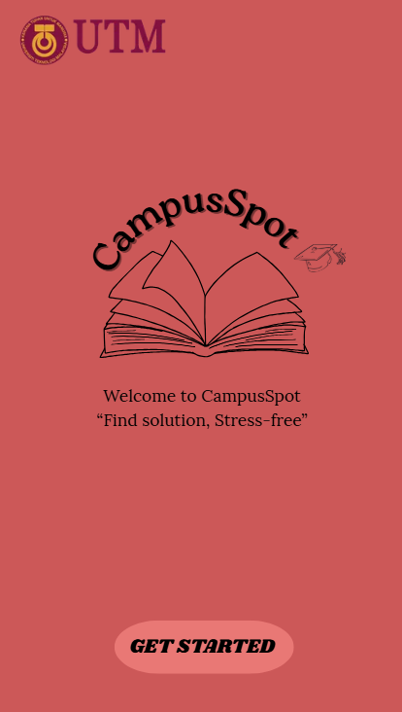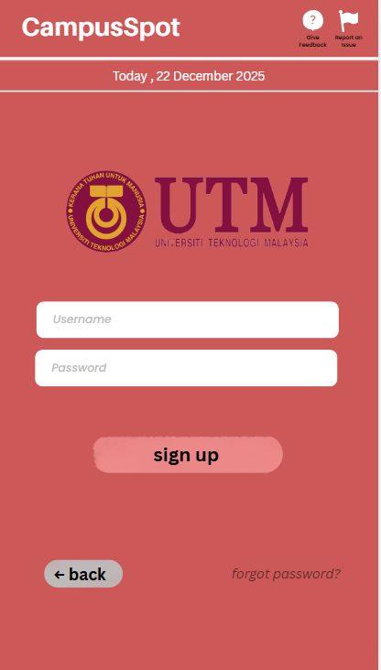
Three option that for choosing the panel which are Smart Parking Map, UTM Flow Tracking and Smart Recommendation | 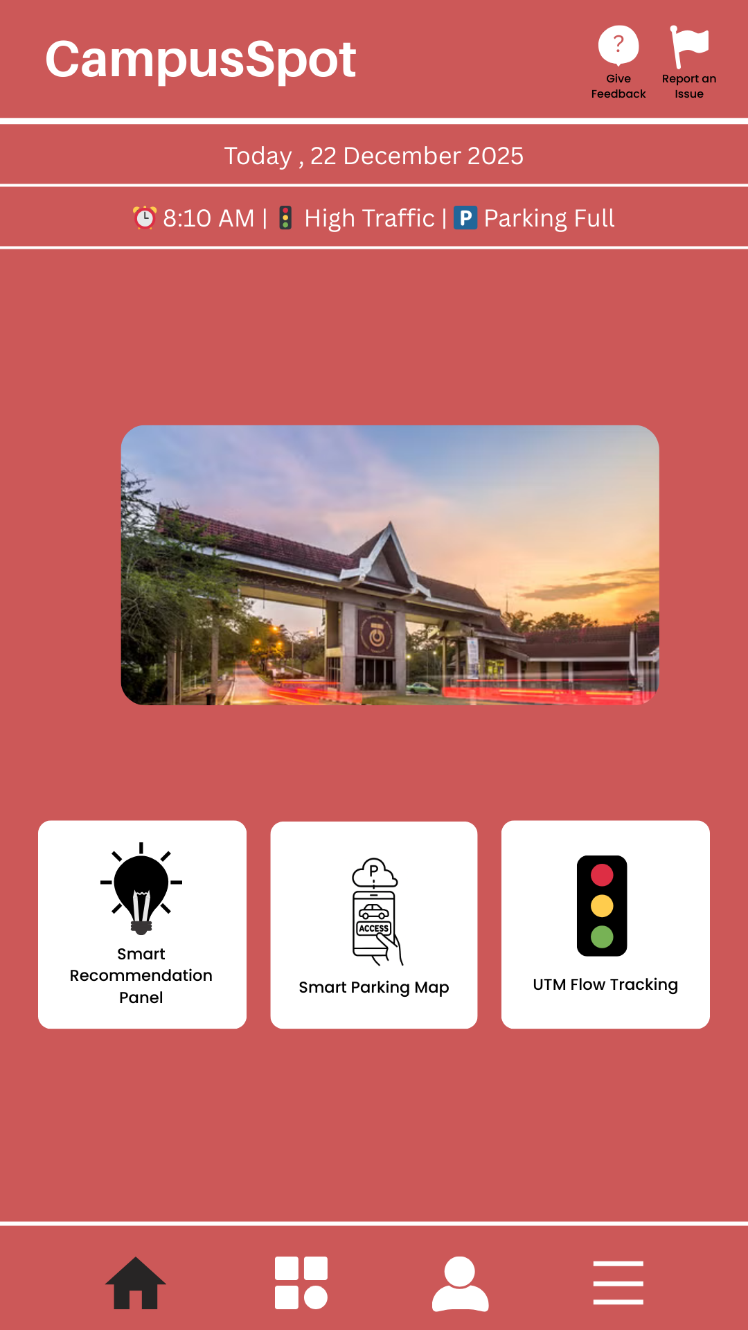
The prototype show the Smart Recommendation that has two option choice which is Parking Suggestion Card and Time Suggestion Card | 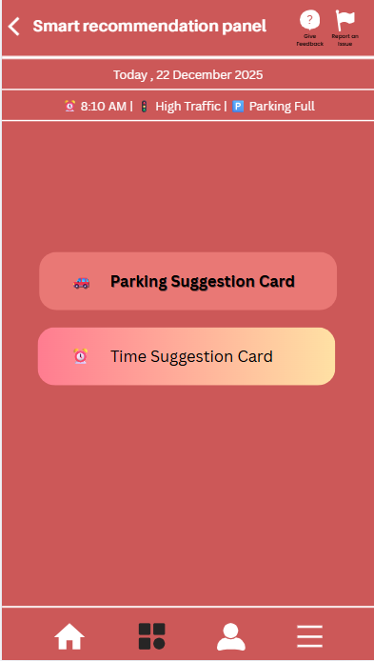
In the Parking Suggestion Card and the Suggestion Card that has some notice to advise user | 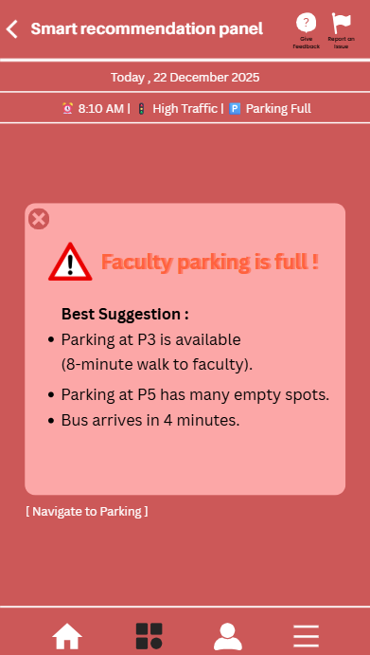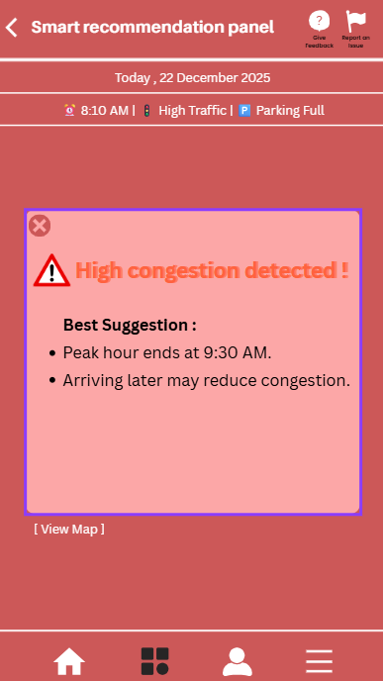
The prototype show the Smart Parking Map shows you available parking spots in real time, so you can find a space quickly and get on with your day.The timer will alway auto-update time.The example of live map area is showed in prototype.The parking space layout ,available parking and the fully of parking are showed in Live Map Area. That is a buttom that write tracking the status at the bottom and just one tap to access it. | 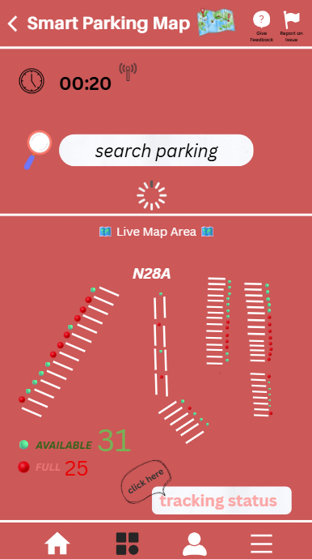
The prototype shows the tracking status that tap the buttom previous in prototype Smart Parking Map. User should set notification interval for getting live updates periodly.When tap the button yes, the system will got notification as the example below the “example what you will get after click to tracking status”showed in the prototype.The user is reminder to keep the phone sound is on.When click no,it will go back to the prototype Smart Parking Map. | 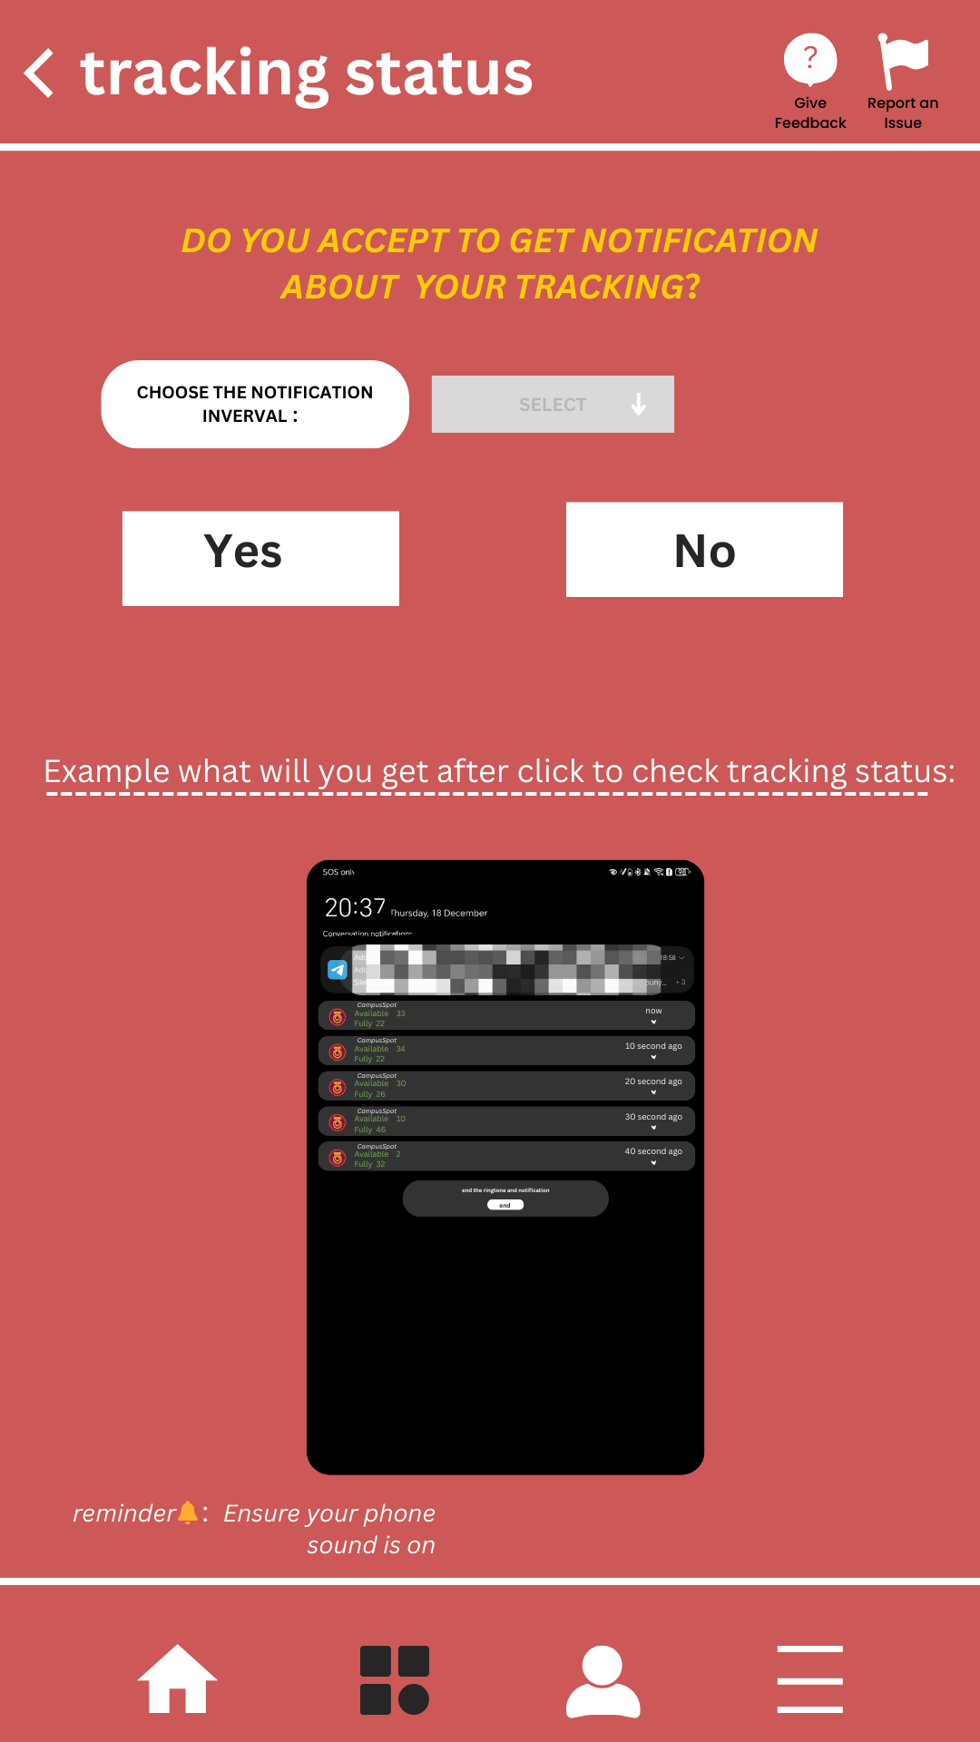
The prototype shows the UTM Flow Tracking. User should pinpoint their location by opening their location or enter location and then user should enter the location where they go. The live status will show the map that the location to go and the condition of road. All route to destination will give supporting by vehicles moving, active users, flow, condition road and emergency. To get route, user can click the google map. | 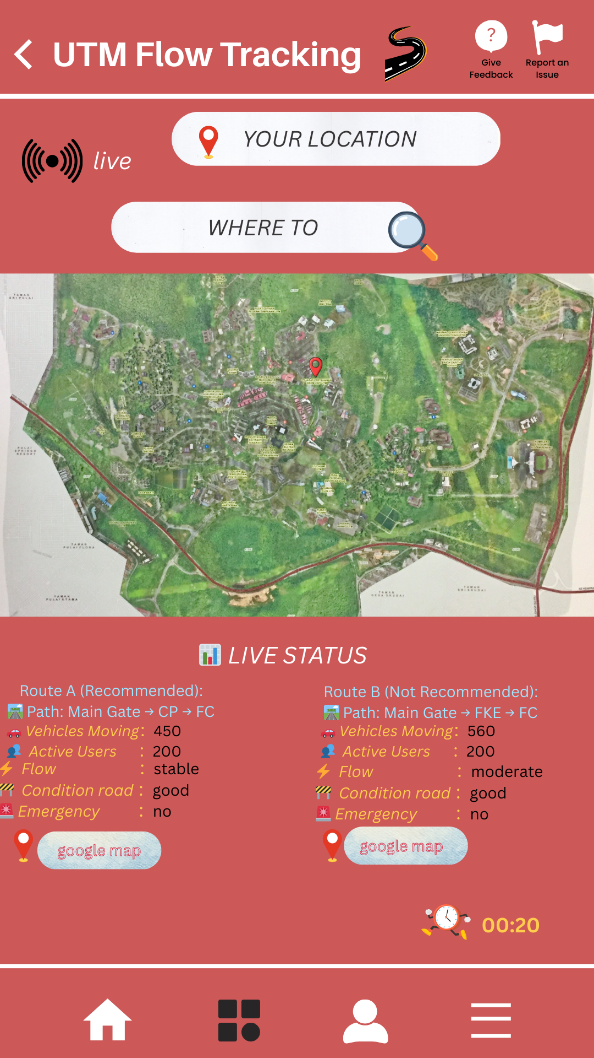
The prototype show the user profile.Activity of the user can be checked and user can choose the language which is english,chinese and malay. To obtain more information user can click the Know about “CampusSpot”.To ensure the security purpose , FaceID and password authentication can be set up.The theme can also be change based on the user’s preferences and comfort. | 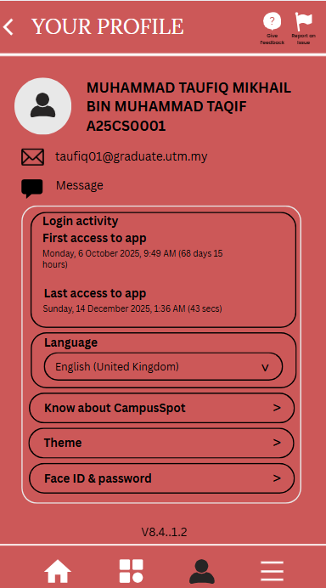
The Settings center lets you manage your account, notifications, vehicle info, and preferences all in one place. | 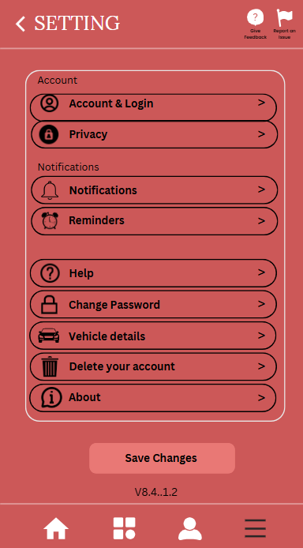
The prototype shows the feedback form and report. The user can enter their suggestion and report some specific issues. Then, click submit our platform will get the feedback from the user and do the improvement. | Feedback form  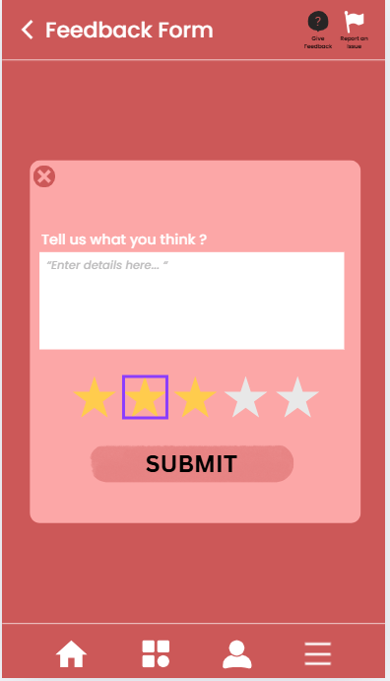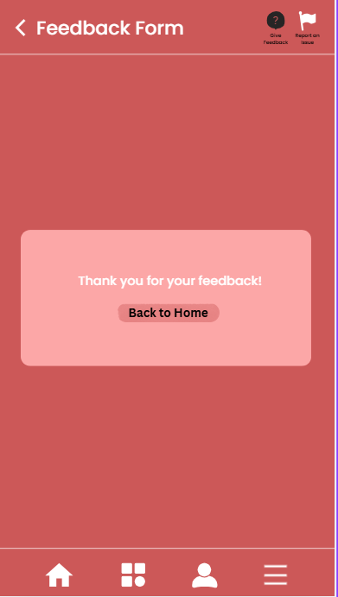  Report Form  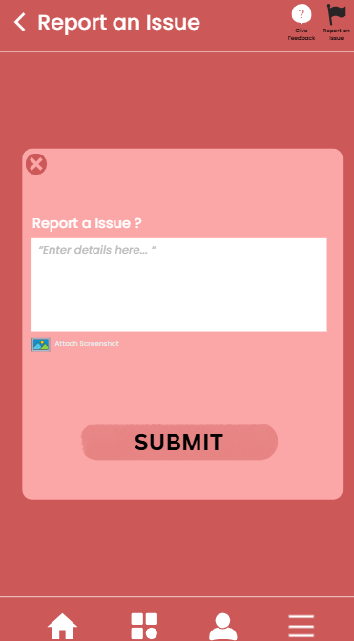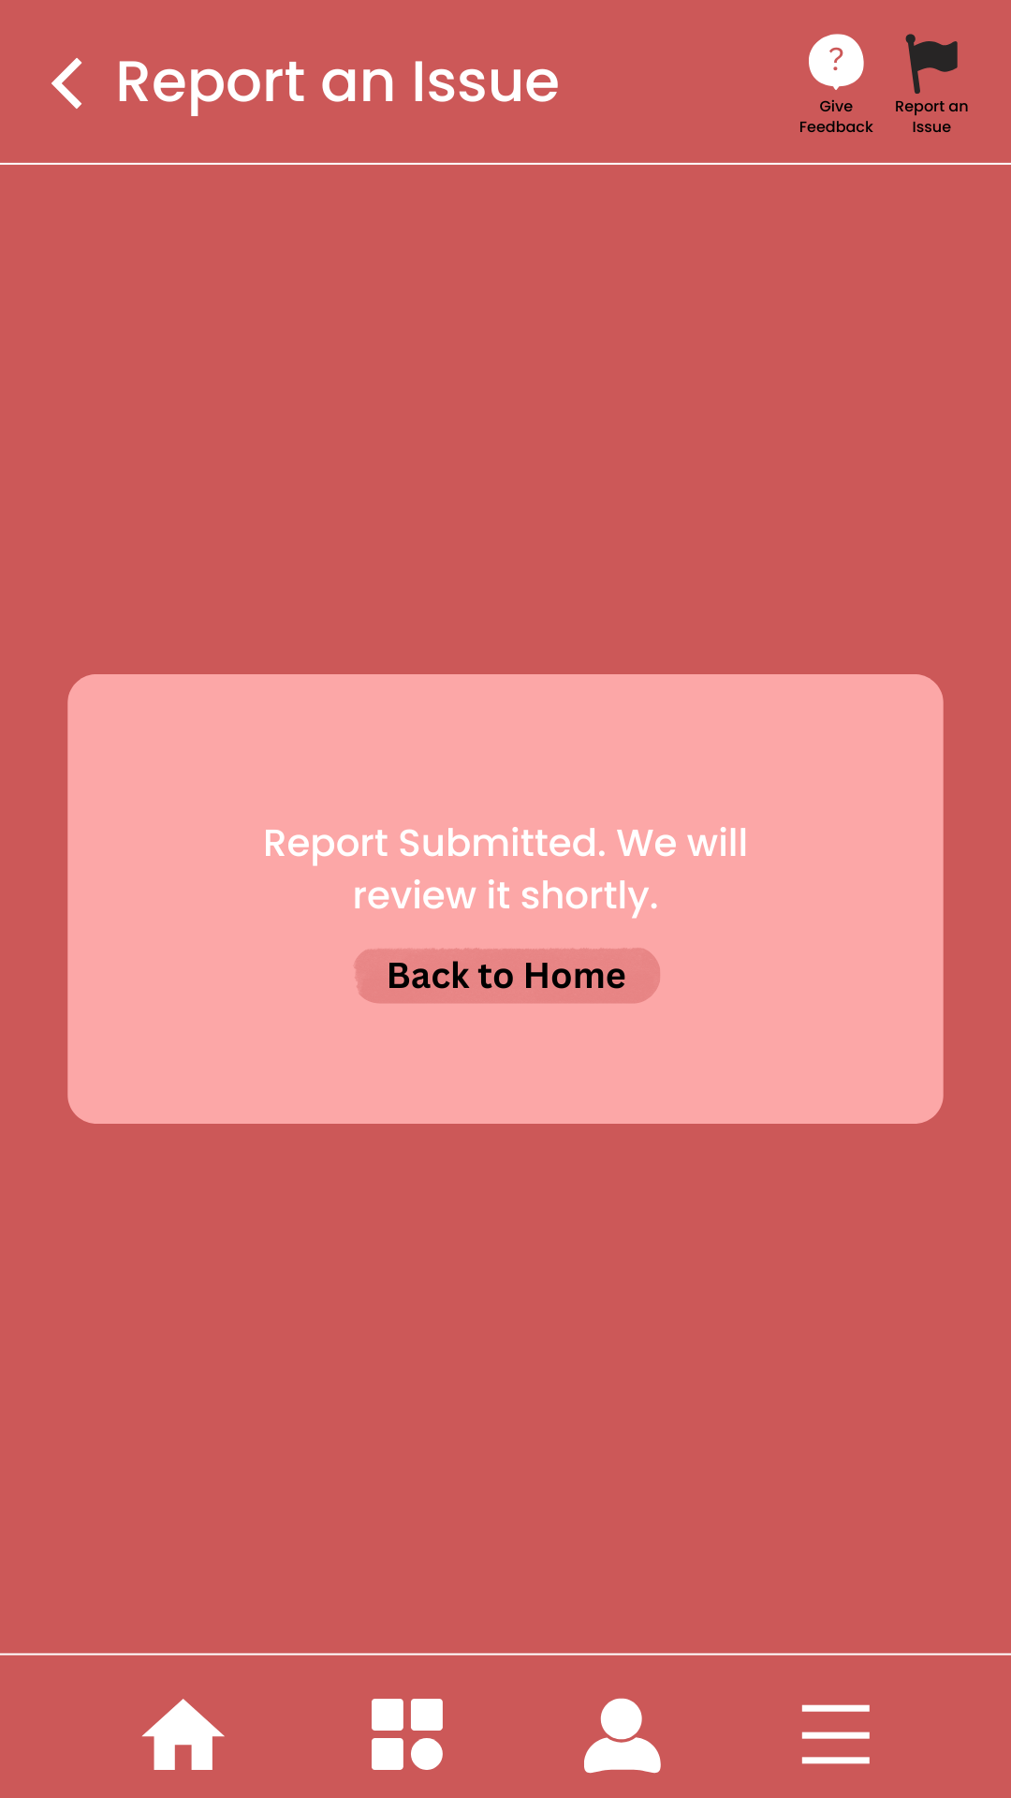
Table 5.2.2.5 Showcase of “CampusSpot”
Through the table Showcase of “CampusSpot” show that the application is an all-in-one campus mobile app that combine real-time parking navigation, routes suggestion, personalized setting and feedback form to make user more effective in campus and stress-free.

5.Test
Once our “CampusSpot” prototype was completed, we presented it to Miss Soffia, who commended its, who commended its practical design and functionality. Recognizing the feedback from Miss Soffia, she specifically praised the intuitive design and noted that real-time parking tracking, and data-driven route suggestion are effectively targeting the student face like traffic congestion and unavailable parking slot.

5.3 Design Thinking Assessment

5.3.1 During the end of the project demonstration
To conclude our project demonstration, our group has created an app called “CampusSpot”. “CampusSpot” application was developed to improve parking space usage around the campus. To understand the issues faced by users, we are gathering feedback through surveys and interviews with students and staff. This feedback helping us to understand the problems related to parking. Based on this data, our group has generated ideas and designed features aimed at making parking more efficient and convenient. Team discussions were held to ensure agreement on the final concept and ensure the apps’s design worked effectively. The final demonstration presented the main features of the application, showing how it could help solve actual parking issues on campus.

5.3.2 During the transition between design thinking phases
In the transition between phases of design thinking process, during the Empathize phases we conducted a survey via google form and interview to collect data about the parking space issues faced by the student and staff. We analyze the problems and find the solution that meets everyone's needs before moving to ideation phases, where we discuss and brainstorm the potential solutions. During the discussion we ensure that each idea that we agree on will address the identified issues effectively. After we are selecting the best solution, we start to build a prototype and conduct early testing to gather feedback that informed improvement before moving to the next phases. This ongoing assessment between phases allowed us to identify problems early and ensure that “CampusSpot” meets the needs of the users.

6.0 Reflections
  - What is your goal/dream with regard to your course/program?
  - How does this design thinking impact on your goal/dream with regard to your program?
  - What is the action/improvement/plan necessary for you to improve your potential in the industry?
NAME | REFLECTION
LIM LI NING | - My goal to become a professional data engineer. Since my course is data engineering, I should more struggle to design, build data robust, manage infrastructure, ensure quality and more essential is collaborate with my team. Not only that, keep learning all of the basic skill and softskill to feel more confident in preparing for my future career in computer science.  - This project enhace my communication skill between different ethnic. Before this project, I felt that generation gap with my teammates. However, as we work together we solve the problem together and contribute the ideas to finished the project, the communication between ethinic much easier. Besided that, I learn the writing skill through the report of the project. Actually, writting isn’t my strongest suit but working on this report gave me a change to practice it. For instance, using design thinking forced me to really learn the details of loT. I believe that this skill help me better in my future career and also the next project and assigment.  - To enhance my potential in the industry, I plan to more reading to generate more ideas about design thinking and gain deeper insights through youtube, news and other platform. I also will focus more on understanding concepts and keep learning whatever in future or currently. Additionaly, I will do more project by joining club which is Airost to learn more.
NAJLA AUNI BINTI MOHAMAD ASRI | - Working with data has always been my dream, and the Data Engineering course is the initial step I take to gain a strong foundation in data management, programming, and analytics. My aim is to master the skills required for handling large datasets in terms of gathering, processing, and analyzing them quickly and easily. I aspire to be an effective and professional data engineer who is involved in the production of data pipelines and systems that empower industries with the power of data-driven decision-making.  - Design thinking is a methodology that helps me to see challenges in a creative way as well as in a structured way. I can achieve that through the user empathy, problem definition, solution brainstorming, prototyping, and testing process to find the least complex and most user-friendly data solutions. With this mindset, I not only limit myself to coding or data manipulation but also come to understand how the data solutions affect real-world decisions; this is in line with my aim of being a powerful data engineer.  - To make myself more valuable in the field of data engineering, I will make it a point to practice programming languages, particularly Python and SQL, on a regular basis. Besides, I will work on small personal projects to acquire practical skills in data collection, cleaning and analysis, and I will participate in workshops, competitions, or internships for the sake of gaining industry exposure. Not only that, but I will also be applying design thinking all the time to come up with creative ways to solve problems and develop solutions that are both efficient and user-focused.
NURAIN NABILAH BINTI AZMAN | - Enrolling in Computer Science is one of the biggest steps I ever took as I have never been involved in any Computer Science related course in my school, so my goal is to build a strong foundation in data management, programming, and solving problems related to Computer. Besides that, my goal is to improve my soft and hard skills. Because Data Engineer is the course  that I focused on, I hope to be a professional data engineer who can design, create, and manage reliable data systems. I eagerly look forward to the chance to work in a job related to data engineering.  - In my opinion, Design Thinking project has helped me to improve my soft and hard skills. Through this design thinking, I’ve developed important soft skills such as communication, teamwork, time management, problem-solving, and critical thinking. Furthermore, working with my teammates really helped me develop a deep understanding of how to write a proper report. I also gained a lot of experience such as creating a prototype, editing a video presentation, and I've gained confidence to embrace myself to share my opinions and ideas in a team.  - In the future, I plan to actively involve myself in club and community activities to enhance my soft skills. I also aim to improve my time management and develop my leadership skills by taking on responsibilities and working with others. Next, I plan to participate in programs related to technology to gain more exposure to technology such as IT and AI to make myself stand out for my resume in the future. I also aim to build strong connections with the company of my dreams by joining or participating in programs provided by the company such as industry talk, mini projects for students and so on.

7.0 References
UTM Smart Transportation Survey. (n.d.). Google Docs. https://docs.google.com/forms/d/e/1FAIpQLSc9413fogHBzAm8hbIJFRvE1pYukO9hlUmqUqucU4vrzMysAA/viewform

Video Link : https://youtu.be/L8OORM-LJPc?si=i3AjkzT-zcsuvo_s

